Exercise: Data Analysis Using R

> setwd("~/Documents/RProjects")

Analysis of binomial.csv

> binomial = read.csv("binomial.csv", header=FALSE)

> summary(binomial)

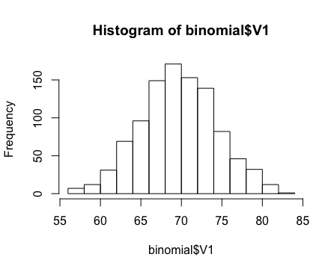 V1

Min. :57.00

1st Qu.:67.00

Median :70.00

Mean :70.17

3rd Qu.:73.00

Max. :84.00

> sd(binomial$V1)

[1] 4.689325

> var(binomial$V1)

[1] 21.98977

> hist(binomial$V1)

Analysis of bn1.csv

> bn1 = read.csv("bn1.csv", header=FALSE)

> summary(bn1)

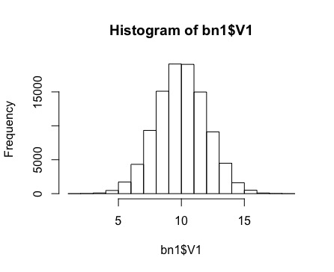 V1

Min. : 1.781

1st Qu.: 8.643

Median : 9.993

Mean : 9.994

3rd Qu.:11.343

Max. :18.612

> sd(bn1$V1)

[1] 2.000357

> var(bn1$V1)

[1] 4.001427

> hist(bn1$V1)

Analysis of bn2.csv

> bn2 = read.csv("bn2.csv", header=FALSE)

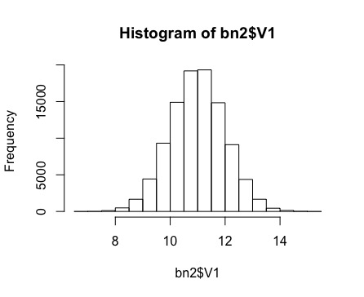> summary(bn2)

V1

Min. : 6.638

1st Qu.:10.321

Median :10.998

Mean :10.997

3rd Qu.:11.667

Max. :15.161

> sd(bn2$V1)

[1] 0.9994714

> var(bn2$V1)

[1] 0.9989431

> hist(bn2$V1)

Analysis of ln.csv

> ln = read.csv("ln.csv", header=FALSE)

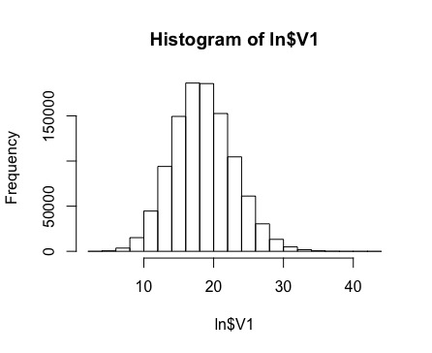> summary(ln)

V1

Min. : 3.00

1st Qu.:16.00

Median :19.00

Mean :18.99

3rd Qu.:22.00

Max. :43.00

> sd(ln$V1)

[1] 4.362612

> var(ln$V1)

[1] 19.03238

> hist(ln$V1)

Analysis of n1.csv

> n1 = read.csv("n1.csv", header=FALSE)

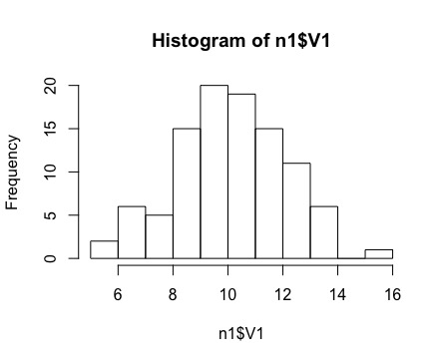> summary(n1)

V1

Min. : 5.064

1st Qu.: 8.774

Median :10.093

Mean :10.134

3rd Qu.:11.458

Max. :15.767

> sd(n1$V1)

[1] 1.995706

> var(n1$V1)

[1] 3.982841

> hist(n1$V1)

Analysis of n1.csv

> n2 = read.csv("n2.csv", header=FALSE)

> summary(n2)

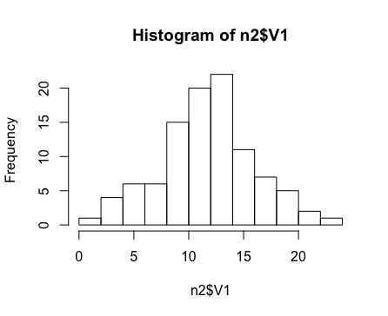 V1

Min. : 0.6503

1st Qu.: 9.0030

Median :11.9056

Mean :11.7082

3rd Qu.:14.1246

Max. :22.6275

> sd(n2$V1)

[1] 4.291276

> var(n2$V1)

[1] 18.41505

> hist(n2$V1)